1. Largest Rectangle in Histogram

Hard

Given *n* non-negative integers representing the histogram’s bar height where the width of each bar is 1, find the area of largest rectangle in the histogram.

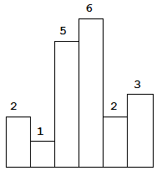 Above is a histogram where width of each bar is 1, given height = [2,1,5,6,2,3].

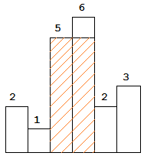 The largest rectangle is shown in the shaded area, which has area = 10 unit.

**Example:**

Input: [2,1,5,6,2,3]  
Output: 10

**解**

解法1 暴力。对于每个条柱，计算最左延申的范围和最右延申的范围，时间复杂度为 $O(N^{2})$

超时。。。。

解法2 使用栈。对于每个条柱，试图计算它能形成的面积

case1

<figure>  
 <img src="..\pic\84_case1.png" width=300>  
 <figureCaption>case1</figureCaption>  
 <img src="..\pic\84_case2.png" width = 300>  
 <figureCaption>case2</figureCaption>  
</figure>

条柱i的右边界一定是i，不会继续扩展

case2

条柱i的左边界一定是i，不会继续扩展

因此对于case1，计算最大面积；对于case2，将i入栈即可